 | 
Laboratory 7: Location-Based Smart Notification using Telegram + Home Assistant | School of Applied Digital Technology
Name:  Name: | ID:  ID: | Section:  Section:
Date: | Due date:

Objectives

Enable Home Assistant to send Telegram alerts with embedded Google Maps location links.

Practice using templated automation messages in Home Assistant.

Allow users to know where an event occurred - e.g., Kitchen, Living Room, Bedroom.

Demonstrate a location-aware Smart Home alert system.

Equipment and Software
Item | Description
💻 Home Assistant (Docker) | Main automation and control system
⚙️ ESP32 + ESPHome | Microcontroller connected to sensors
🌡️ DHT11 | Temperature and humidity sensor
💨 MQ-2 | Gas/smoke detection sensor
🚶 HC-SR501 | Motion detection sensor
🔔 Active Buzzer / LED | Alert device
🤖 Telegram App | Notification receiver
🗺️ Google Maps | Used to view sensor locations

System Concept
When an event occurs (e.g., gas leak, motion, or high temperature), Home Assistant sends a Telegram message with a Google Maps link showing the sensor’s location.
Example Telegram message:
⚠️ Gas leak detected in the kitchen.
📍 See location on map.

1. Define Sensor Coordinates

Assign fixed GPS coordinates for each sensor location:
Location | Latitude | Longitude
Living Room | 13.9123 | 100.5211
Kitchen | 13.9125 | 100.5213
Bedroom | 13.9126 | 100.5215
💡 Tip: To find coordinates, open Google Maps, right-click on a location → “What’s here?” → copy latitude and longitude.
2. Add Automation Rules in Home Assistant
- Edit /config/automations.yaml and add the following:
Yaml:
# =========================================
# 🚨 Gas Detection with Location
# =========================================
- alias: "Alert: Gas Detected with Location"
trigger:
- platform: state
entity_id: binary_sensor.gas_alarm
to: "on"
action:
- service: notify.telegram
data:
message: >
⚠️ Gas detected in Kitchen!
📍 [View on Map](https://maps.google.com/?q=13.9125,100.5213)
- service: switch.turn_on
entity_id: switch.active_buzzer
- delay: "00:00:10"
- service: switch.turn_off
entity_id: switch.active_buzzer

# =========================================
# 🚶 Motion Detection with Location
# =========================================
- alias: "Alert: Motion Detected with Location"
trigger:
- platform: state
entity_id: binary_sensor.living_room_motion
to: "on"
action:
- service: notify.telegram
data:
message: >
🚶 Motion detected in Living Room!
📍 [View on Map](https://maps.google.com/?q=13.9123,100.5211)

# =========================================
# 🌡️ High Temperature with Location
# =========================================
- alias: "Alert: High Temperature with Location"
trigger:
- platform: numeric_state
entity_id: sensor.living_room_temperature
above: 32
action:
- service: notify.telegram
data:
message: >
🔥 High temperature detected!
Current: {{ states('sensor.living_room_temperature') }} °C
📍 [View on Map](https://maps.google.com/?q=13.9126,100.5215)

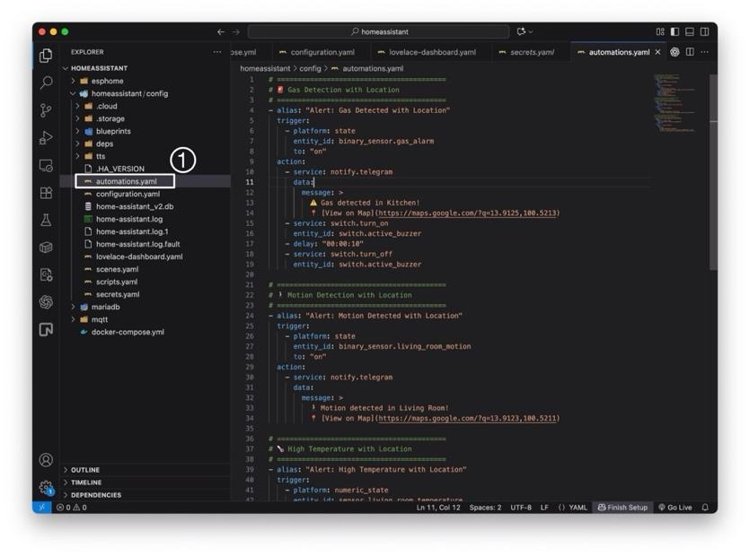
3. Validate and Reload Automations
- Go to Developer Tools → YAML → Check Configuration to ensure no syntax errors.
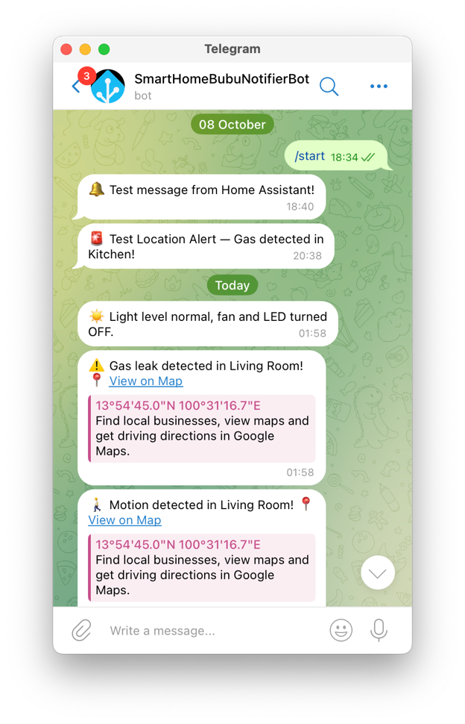
- Then go to Developer Tools → Actions and execute:
Yaml:
action: automation.reload
target: {}
data: {}
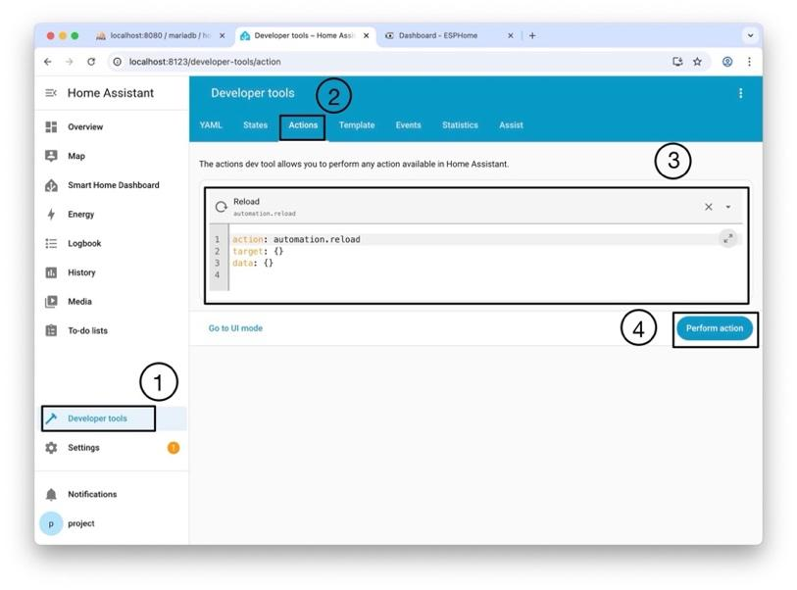
- Once reloaded, your new automations are active ✅

Take 1: Design and Implement a Smart Unified Notification System for Multiple Events
Objective:
To design and implement a location-aware smart notification system in Home Assistant that can detect multiple simultaneous events (Gas Leak, Motion, and High Temperature) and send a single summarized alert to Telegram — instead of multiple separate messages.
Requirements:
- Hardware and Platform
• Use an ESP32 or ESP8266 board integrated with ESPHome.
• Use the following sensors:
• MQ-2 gas sensor → detects gas or smoke.
• HC-SR501 motion sensor → detects movement.
• DHT11 sensor → measures temperature and humidity.
• All sensors must be connected and registered in Home Assistant.
- Automation and Notification
• Create a single automation in Home Assistant that combines all three triggers:
• Gas sensor (binary_sensor.gas_alarm)
• Motion sensor (binary_sensor.living_room_motion)
• Temperature sensor (sensor.living_room_temperature)
• The automation should:
• Wait for 5 seconds to ensure all events occurring close in time are grouped.
• Collect current values of all sensors.
• Send one unified message to Telegram that summarizes all detected events.
• Include the current time and Google Maps location link of the affected area.
Code:

----- Have a good day -----
Answer:
- alias: "Smart Unified Alert"
description: "Combine gas, motion, and temperature events into one Telegram message"
mode: single
trigger:
- platform: state
entity_id:
- binary_sensor.gas_alarm
- binary_sensor.living_room_motion
- platform: numeric_state
entity_id: sensor.living_room_temperature
above: 32
action:
- delay: "00:00:05"
- service: notify.telegram
data:
message: >
🚨 *Smart Unified Alert*
🕒 {{ now().strftime('%H:%M:%S') }}
💨 Gas: {{ states('binary_sensor.gas_alarm') }}
🚶 Motion: {{ states('binary_sensor.living_room_motion') }}
🌡 Temperature: {{ states('sensor.living_room_temperature') }} °C
📍 [View on Map](https://maps.google.com/?q=13.9123,100.5211)

